

Macrovision®

AdminStudio

Setup

Specification

Owner(s) Jigar Desai

Last Updated 11/2/2004 10:05:00 PM

File Name 0000.doc

© 1999 InstallShield Software Corporation. All rights reserved.
THIS IS PRELIMINARY DOCUMENTATION. The information contained in this document represents the current view of InstallShield Software Corporation on the issues discussed as of the date of publication. Because InstallShield must respond to changing market conditions, it should not be interpreted to be a commitment on the part of InstallShield, and InstallShield cannot guarantee the accuracy of any information presented after the date of publication.
This BETA document is for informational purposes only. INSTALLSHIELD MAKES NO WARRANTIES, EXPRESS OR IMPLIED, IN THIS DOCUMENT.
Other product or company names mentioned herein may be the trademarks of their respective owners.
InstallShield Software Corporation • 900 National Parkway • Schaumburg, Illinois 60173-5108

Table of Contents

^{1.0 Abstract} 3
^{2.0 Requirements} 3
3.0 Features Reserved for Future Versions 4
^{4.0 Limitations} 4
^{5.0 Issues} 4
^{6.0 Revision History} 4

^{1.0 Abstract}
This documents outlines the requirements for the AdminStudio setup.

^{2.0 Requirements}
- Perform an upgrade from previous versions of Tuner, IPWI and Express.
- Have a new product code and package code.
- Validate the serial number in the UISequence and ExecuteSequences.
- Launch the registration wizard at the end of the install.
- Setup will consists of the following:
    - 4 top level features – Tuner, IPWI, Repackager and ConflictSolver.
    - All features will be installed on the local machine.
    - Tuner will be installed in <ProgramFiles>\InstallShield\Tuner
    - ConflictSolver will be installed in <ProgramFiles>\InstallShield\ConflictSolver
    - Repackager will be installed in <ProgramFiles>\InstallShield\ Repackager
    - IPWI will be installed in <ProgramFiles>\InstallShield\InstallShield Professional Windows Installer Edition.
- Typical Shortcuts are shown here.

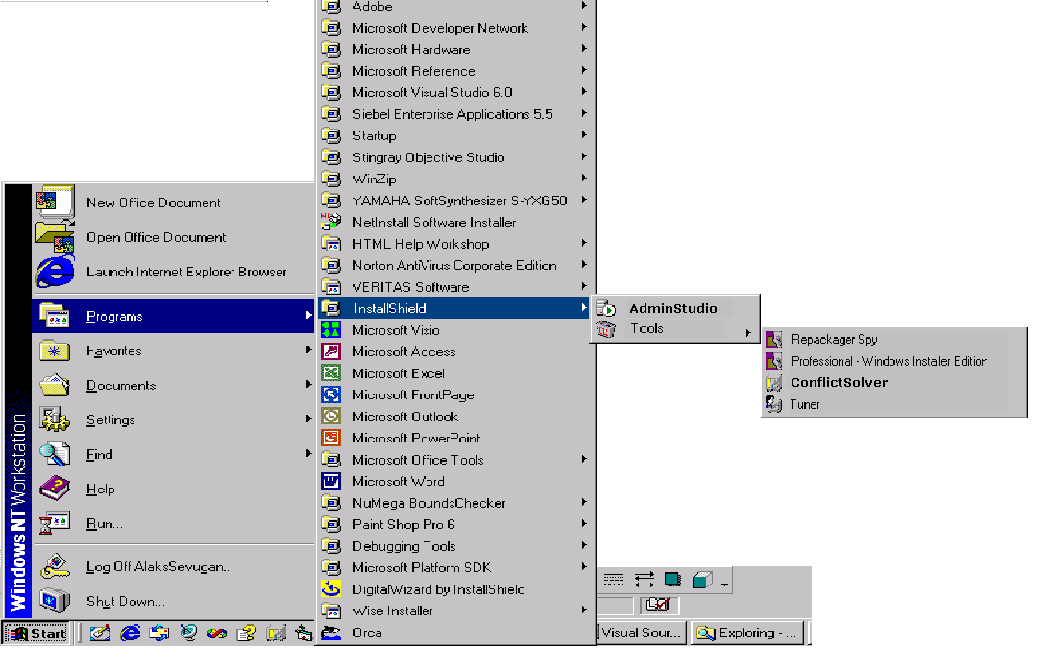

3.0 Features Reserved for Future Versions

^{4.0 Limitations}

^{5.0 Issues}

^{6.0 Revision History}

Date | Author | Change Reference
04/02/2001 | Jigar Desai | Initial Draft

